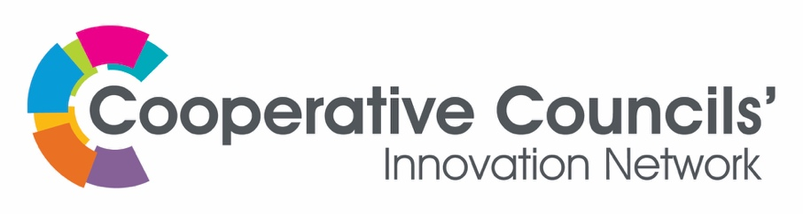

Funding Agreement – CCIN-funded Policy Prototype project

Date:

Between: CCIN and [insert: Lead Council]

Funding Recipient Details
Organisation Name |  | Lead Officer Name
Address
Name | (authorised on behalf of the Project Lead Council)

Funding Details & Payment Schedule
Total Funding Amount (inclusive of any VAT payments) |  | £
Payment Date 1 | Payment Date | Amount
Upon approval of specific documents by the CCIN Values and Principles Board, referred to as the “Project”. | Upon completion of the Project | £
The funded Project | The Project, as outlined in the Bid, submitted by the Lead Council and attached at Appendix 1
Project duration |  | [insert]

- The Funding must be used exclusively to support the Project.

- The CCIN shall make the payment in accordance with the following process:-

  - At least four times a year, you will complete an online template to report on your Project’s progress (“Policy Prototype Delivery Update”) to the V&P Board.
  - The Values and Principles Board receives your Final Report.
  - Once your final report is approved, the report will be submitted for approval to the Executive Oversight Committee (EOC).
  - Once the EOC has approved the report, CCIN will notify you to issue an invoice to request final payment;
  - Payment will be released within 30 days of receipt of the invoice.

- You must provide the CCIN with any further information, materials or requests for information, including full participation in launching the report and engaging with project partners.

- You may be nominated a Project Sponsor from the V&P Board who will support you with your Project throughout its duration (“Project Sponsor”). Project Sponsor:-

  - Will support the Project Lead navigating through the requirements of the V&P Board;
  - Make requests for further information from youn on behalf of the V&P Board;
  - Should be invited to attend relevant meetings related to your Project;
  - Support you in your attendance at any Values and Principles Board meetings

- A final report shall be made by the Lead Officer in person to the Values and Principles Board during an online session. Although you are at liberty to decide the format of that final report, you should refer to the CCIN Brand Guidelines to ensure the final output is to a publishable standard (https://www.councils.coop/membership/ccin-brand-guidelines/). You must acknowledge the support of CCIN in any materials that refer to the Project and in any written or spoken public presentations about the Project.

Final Report

- The Values and Principles Board may make recommendations and/or request further information during and following the Final Report and you shall co-operate with meeting those recommendations and/or requests in a timely manner.

- CCIN may at its discretion, withhold or suspend payment of this Agreement and/or require repayment in the following circumstances:

  - The Funding is used for purposes outside of the original Bid, repayment shall not apply in respect of any funds that have already been used for the purposes set out in the original Bid;

  - The Project Lead fails to provide the Policy Lab Delivery Updates or Final Report within the timescales agreed by the V &P Board;

  - The Project Lead makes an onward payment of any Project funding to any Associate Member transitioning to Full Membership, until that Associate Member has paid their Full Member membership fee;

  - You commit a material or persistent breach (breach means a failure to perform the obligations) of this Agreement that is not capable of being remedied by you or, if capable of remedy you fail to remedy such breach within 30 days after receiving written notice from CCIN requiring you to do so;

  - Where in the reasonable opinion of CCIN any funding secured by you, whether notified to it or otherwise, is duplicate funding for the Project;

  - If you give CCIN any information that is materially inaccurate or misleading, or

  - If you do anything which, in the reasonable opinion of CCIN, brings or is likely to bring CCIN into disrepute or which adversely affects or is likely to affect the fundraising activities of CCIN and its relations with members, donors or other persons.

Dispute Resolution

- Please refer to the CCIN’s Code of Conduct. https://www.councils.coop/about-us/governance/conduct-complaints-procedure/.

Term and Termination

- Policy Prototypes should be delivered within 12 months of the sign-off of the Project. Any variation should be agreed with the V&P Board in writing.

- The Lead Council and the CCIN may terminate this Agreement at any time by 3 months’ notice in writing. On termination, for any reason, the Lead Council shall not be entitled to any further payments from this Agreement.

Signed on behalf of the CCIN | Date:
Signed on behalf of the Lead Council | Date:

Appendices

[insert:
Bid
Communication Plan
The Cooperative Difference
The Work Programme
The Budget
Responsibilities of the Project Partners]

