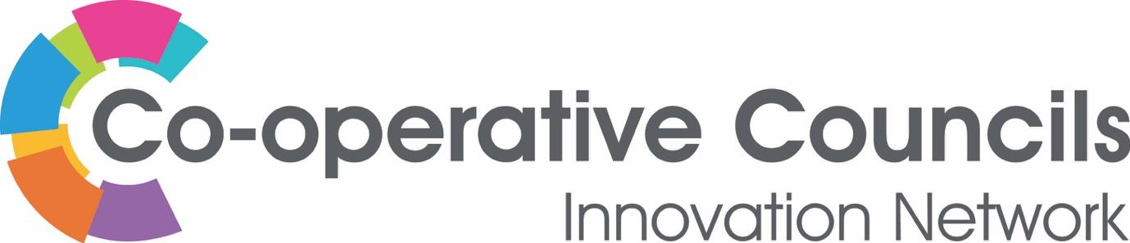
Strategy 2024-6
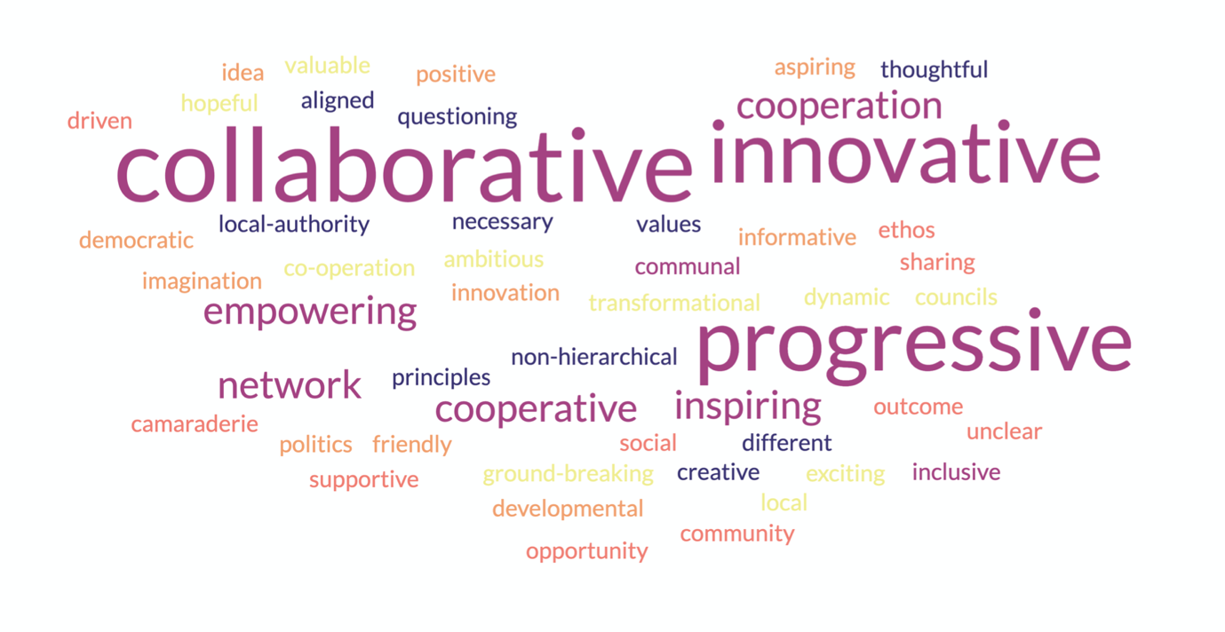
Word cloud - created by the Ideas Alliance in response to a question in the member survey – October 2023: “What does the CCIN mean to you?”

Elevator pitch
UK councils who are driving global public policy development and best practice with a shared belief in Cooperative Values & Principles.

Introduction
Borne out of austerity in 2012, the CCIN is today the fastest-growing non-political Network in local government. As a Special Interest Group of the Local Government Association, we are proud that both councillors and officers are engaged in our work, making it as simple as possible to maximise membership benefits. Our collective work is crucial in facing the cost-of-living crisis and the public sector's financial challenges.

In the summer of 2023, the CCIN commissioned the Ideas Alliance, an Affiliate Member, to support us in reviewing our work and developing a collaboratively produced forward-facing strategy for our next chapter. The Ideas Alliance conducted one-to-one interviews, online sessions, and an online survey for all members to participate. They also organised an in-person workshop for Governance and two workshops during the Annual CCIN conference. The Ideas Alliance report can be downloaded here: https://www.councils.coop/about-us/governance/strategy-2024-2026/.

This new strategy aims to build on our firm foundations. As a growing Network of regional authorities, unitary, district, borough, town, parish and community councils, we believe that building an equal partnership with local people is critical to building resilient communities. By empowering residents, we can create a fairer and more cooperative world. The members of the Network are committed to helping each other translate cooperative principles into practical solutions that will work for our communities and places. We aim to further differentiate the CCIN approach to growing the cooperative economy from other organisations working with the public sector. Our practical action-focused approach, where councillors and officers from all member councils drive the implementation of policy change, is one we are proud of and keen to expand upon.

Vision
Being a member of the network has meant sharing our developing good practices and supporting one another by spotlighting our cooperative values and principles. As we enter our second decade, it is clear from discussions that members are eager to see more of our cooperative ideas and approaches percolate throughout their organisations to build a movement of cooperative ideals within local government. With the election of a new Government, members are excited for the opportunity to showcase the difference that the Cooperative Council's approach to service delivery is making in communities. Seeing how the Network has become a focus for creating positive change for the benefit of communities across the UK is inspiring.

Over the last decade, the Network has reinvested more than £400k of membership fees in member-led policy projects and organised international study visits for members to experience cooperative working across Europe. As we move forward, it is the perfect time to review how we invest those funds to build a broad range of champions in cooperative service delivery and thematic areas. This will ensure that the learning from this policy work supports council decision-making across the network. The Network is committed to investing in its members and working towards creating positive change in the community.

Embedding ownership of this strategy across the network is critical to creating a cooperative council movement.

Plan on a page

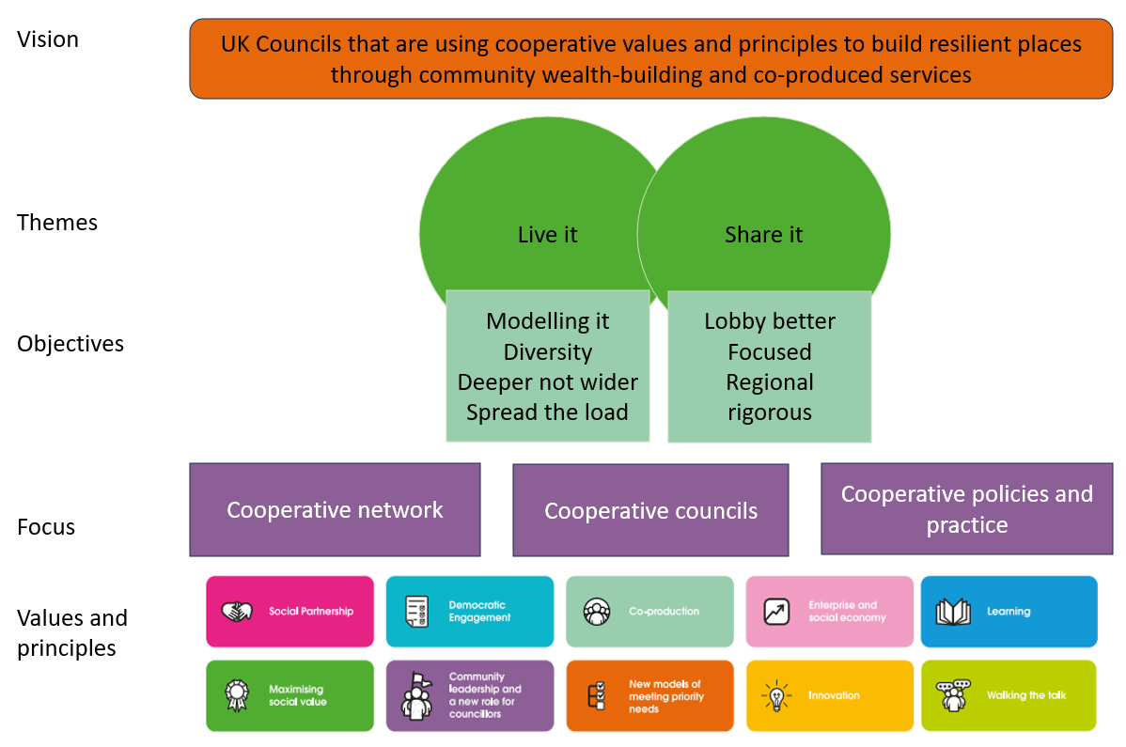
A cooperative network:
Objective | A cooperative network - A broad and welcoming network that functions as a cooperative with everyone both contributing to and benefitting from the work

Measures | July 2021 | July 2022 | July 2023 | July 2024  (Provisional) | July 2025  Target | July 2026  Target
Full Council Members | 33 | 34 | 45 | 47 | Improving trend | Improving trend
Associate Members* | 20 | 22 | 23 | 22 | Improving trend | Improving trend
Town and Parish Councils* | 10 | 10 | 12 | 13 | Improving trend | Improving trend
Affiliate Member | 36 | 44 | 49 | 49 | Improving trend | Improving trend
Supporters | 14 | 21 | 21 | 24 | Improving trend | Improving trend
Case studies | Over 300 | Over 420 | 478 | 535 | Improving trend | Improving trend
* Town and Parish Councils are included within the Associate Members’ total

 | Supporting Activity | Lead | Milestone | Progress
1.1 | - Defining the legal structure fit for the type of organisation CCIN wants to become | Cllr Mike Stubbs and Claire Ward | Summer 2024 | On track
1.2 | - Reviewing the CCIN’s financial processes | F&GPG
1.3 | - Be clearer about Member Benefits and encouraging more officers and members to engage
1.4 | - explore technology-based solutions that enable people to engage in different ways and to self-organise (including whats app, discussion boards and other approaches)  - Define ‘rules of engagement’ for what’s app  - Automate sign up to sector/thematic what’s app groups  - Trial the use of the LGA Knowledge Hub forum  - Trial the use of the NewSocial forum | Morgan Jones  Simon Grove-White | Summer 2024  Summer 2024 | On track
1.5 | - Encouraging and engaging non labour- led councils to participate in and lead our funded policy labs – eg, Lib Dem, Green, SNP
1.6 | - Developing template motions for members to use in order to drive cooperative policy through their own organisations  (linked to action 2.3) | Claire Ward
1.7 | - Have a national VCSE rep on the V&P Board to be a community voice
1.8 | - Creating staffing structure to deliver the new strategy. | Nicola Huckerby
1.9 | - Consider how we could market the Network differently to attract different members
1.10 | - From a National perspective discussions can sometimes be English centric so there is a role for Scottish and Welsh Councils to highlight those difference and in order to expand the Network in those countries.
1.11 | - Podcasts – monthly about what being a member means. Look at how cost-effective this could be. | (Andrew Laird / Paul Bell to support NH on this).
1.12 | - Living the cooperative value of ‘self-responsibility’ so expectations on what can be done from the centre are practical.
1.13 | Could GMCA lead on a regional approach that could be used in other regions. Do same for other regions – eg London and North East.  Could this approach work for National groups with Scottish and Welsh members working together.
1.14 | - Identify/recruit regional Champions to work with thematic/service leads encouraging more working at a local level so learning from Policy Labs is embedded. | Member Councils could be asked to identify their Champions as a follow up to the application process
1.15 | - From a National perspective discussions can sometimes be English centric so there is a role for Scottish and Welsh Councils to highlight those difference and in order to expand the Network in those countries | Cllr David Darkin offered to support increase membership in Wales including translation.
1.16 | - Develop a Welcome Pack for new members of the Network | Nicola Huckerby | Summer 2024 | Complete

Made up of cooperative councils:
Objective | Cooperative councils - Support existing CCIN members to deepen engagement with cooperative practice throughout their organisation

Measures | July 2022 | July 2023 | July 2024  (Provisional) | July 2025  Target | July 2026  Target
Full Council Members | 34 | 45 | 46
Policy Labs:
Number of Policy Labs | 8 | 6 | 4
Number of Councils participating in Policy Labs | 25 | 26 | 25 | Improving trend | Improving trend
Percentage participation | 74% | 58% | 54% | Improving trend | Improving trend
Policy Prototypes:
Number of Policy Prototypes | 2 | 7 | 5
Number of Councils participating in Policy Prototypes | 2 | 7 | 5 | Improving trend | Improving trend
Percentage | 6% | 16% | 11% | Improving trend | Improving trend
Meetings and events | 10 | 12 | TBC
Notes
The Budget for policy projects has remained constant at £75k, with £ 60k allocated for Policy Labs and £15k for Policy Prototypes. In 2024, the amount available for a Policy Lab increased from £10k to £20k to allow for more complex reports. The amount available for Policy Prototypes also increased from £1,500 to £2,000. The Policy Labs listed above include the Study Visits funded and delivered by the Network.
Events and meetings are taken from the annual review and include attendance at political conferences. They do not include regular member and officers’ meetings, or meetings to take forward specific Policy Labs.

Other potential measures:
Number of sign-ups to the CCIN newsletter / engagement with the newsletter
Percentage of invitee attendance at member and officer meetings?
Percentage of members represented / No of attendees at annual conference?

 | Supporting Activity | Lead | Milestone | Progress
2.1 | - Develop a plan on how to run session on ‘being a coop council’.  (Tamworth is running one on Coop messaging. Kirklees is keen to organise something on this. Stevenage is running 1 to 1 sessions for all the candidates in the local elections on what it means to be a coop council in conjunction with the Coop Party.)
2.2 | - CCIN Cabinet Champions create job description/role responsibilities for a cabinet member Champion (Brent and Stevenage already have these roles) | Claire Ward
2.3 | - Include ‘Being a Coop Council’ training session in the Welcome Pack for members to deliver themselves locally.  (linked to action 1.6) | Nicola Huckerby | Autumn 2024 | On track
2.4 | - Examples of how to embed our Cooperative Principles into council services. | Opportunity for coop heritage trust and a member council
2.5 | - Short videos explaining why councils, groups and other organisations should join. Reuse film made from Anniversary video | Nicola Huckerby | Autumn 2024 (started) | Complete

Developing cooperative policies and practice
Objective | Develop cooperative policies and practice. Develop a strong story of the change you want to see - grow policy expertise, capacity and case studies that demonstrate the effectiveness of cooperative approaches.

Measures | - Media coverage of CCIN approaches outside the cooperative press (this would mean paying for a media coverage report)  - Increased traffic to the CCIN website (NB google analytics cannot separate out CCIN member and non-member website visits)  - CCIN attendance at political conferences

 | Supporting Activity | Lead | Milestone | Progress
3.1 | - Review the Policy Lab approach to focus on key policy areas
3.2 | - Strengthen the role of the Officers Network to become ‘experts or champions’ on specific themes – starting with the Policy Lab Leads.
3.3 | - Define clear expectations on what leading on a Policy Lab means (not just about submitting and launching a report) | Nicola Huckerby | Summer 2024 | On track
3.4 | - Publish a revised brand guideline and cooperative identity toolkit | Nicola Huckerby | Summer 2024 | On track
3.5 | - Establish Policy Project Champions from the Values and Principles Board to guide councils through the process of project delivery | Values and Principles Board
3.6 | - Review previous Policy Lab reports – who has learnt from them and what has actually changed since a report was completed? | Morgan Jones | February 2024 | On track
3.7 | - Developing resources for others to pick up.
3.8 | - Current DPS runs until 2025 – review the ease of access for both organisations to get on to it, and for councils to use it.
3.9 | - Webinars events to engage more members and officers, particularly those that don’t attend the events we support | Nicola Huckerby | November 2024 | On track

