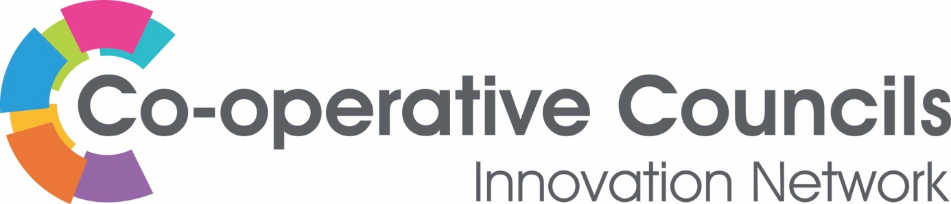

COMMUNITY

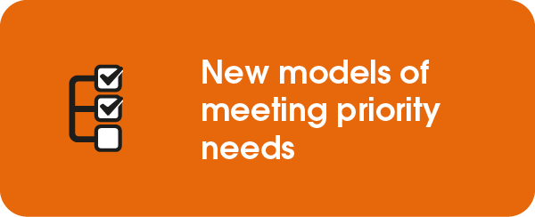

Rochdale Borough Council

Blooming Community Spaces in Rochdale
Rochdale In Bloom is part of the Royal Horticultural Society’s ‘Britain In Bloom’ competition. Whilst there is a competitive element, it provides a powerful tool for building communities and tackling local issues together.

Rochdale’s In Bloom offer is, unusually, not managed by the local authority. Citizens are equal partners in designing the programme, which is overseen by an enthusiastic group of volunteers. It has flourished from a small team to a large collaborative network of community groups, private businesses, schools, individuals and the local authority.

Whilst it is not a formal co-operative, it remains true to Rochdale’s co-operative heritage and is rooted in the values of self-help, self-responsibility, equity, equality and solidarity. There is a strong sense of mutual ownership and support, which is key to the continued growth and development of the project. As the chair of Rochdale In Bloom observed “Co-operation ~ It’s in our DNA”

Intrinsic to the success of the offer in Rochdale is an understanding of the borough’s demographic and a desire to build an offer which spans communities. Most importantly the offer is diverse and inclusive. Rochdale is justly proud to be the only borough to have a ‘Mosques in Bloom’ offer. They work hard to build community links and tackle gaps in social infrastructure. This creates the co-benefits of an attractive green environment in which Rochdale residents can take pride and get involved with, while in turn, strengthening community ties. It is aiming to continue to increase the number of community organisations entries to the “In Your Neighbourhood” category which reached an amazing 58 schemes in 2023.

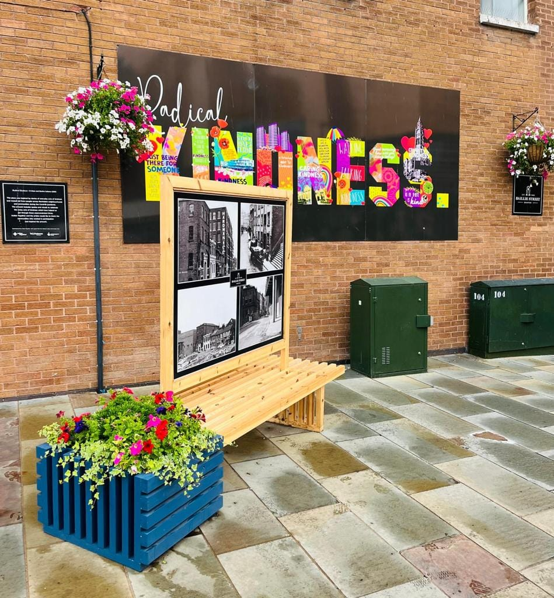

It works hard to transform spaces whilst benefitting communities. Volunteers have developed an outdoor learning Centre from an unused piece of land, while simultaneously learning about the environment and natural habitats. This now functions as a forest school for five primary schools in densely urban areas, where children may have less opportunity to access green space.

There is ongoing work with Petrus, an organisation working with people at risk of homelessness, to create and maintain a therapeutic garden. The ‘plot to plate project’, helps address the cost of living crisis. It encourages residents to grow their own produce in community growing spaces to reduce their living costs. Any surplus is donated to the town’s foodbanks to help address food poverty in Rochdale.

Rochdale in Bloom is viewed as an exemplar and is increasingly called on by other In Bloom groups, providing support outside of Rochdale’s boundaries and demonstrating its unique co-operative approach.

___________________________________________________________________

For further information contact:

Helen Walton
Policy Adviser – Rochdale Borough Council
helen.walton@rochdale.gov.uk/ | 01706 924748 | www.rochdale.gov.uk

