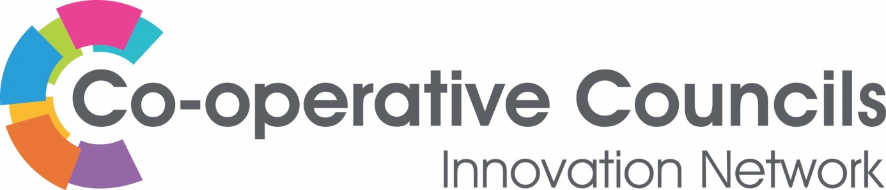

POVERTY

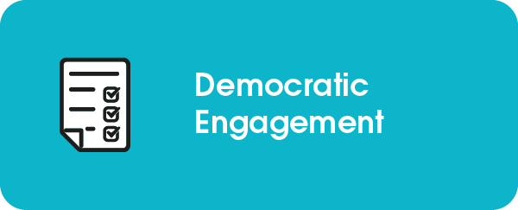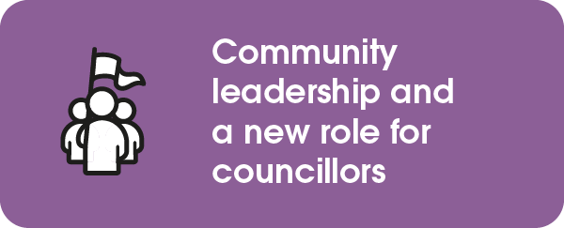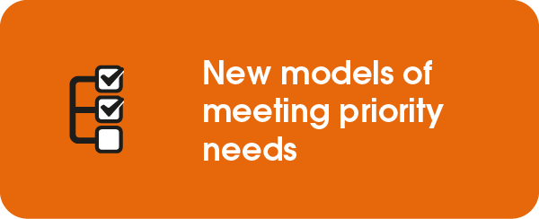

Rochdale Borough Council

A Co-operative Approach to Poverty Prevention
Rochdale is ranked the 15th most deprived borough in England based on a rank of the average for LSOAs in the area (defined in the Indices of Deprivation). Recent statistics from the End Poverty Coalition estimate that child poverty has increased in Rochdale borough from 32.9% in 2014/15 to 40.5% in 2021/22. In the ward with the highest child poverty rate, half of all children are living in poverty. The Greater Manchester Poverty Action's (GMPA) 'Poverty Monitor' shows that 15% of Rochdale residents are in fuel poverty and 12% are struggling with food insecurity.

The Council is finalising its anti-poverty strategy - ‘The Future we Deserve’. Its aim is to provide a life raft for families who are struggling to stay afloat. Rochdale is the birthplace of co-operation and a co-operative spirit permeates the borough. In order to make meaningful change for those experiencing poverty, we must to galvanise that co-operative spirit.
The Council has worked collaboratively with a broad range of partner organisations, the Voluntary, Community, Faith and Social Enterprise (VCFSE) sector, through its partnership with Action Together and people with lived experience of poverty to devise and design the strategy. In early 2023 several listening events and anti-poverty summits took place, bringing partners together with those who have a lived experience of poverty. Through a combination of listening, workshops and action planning, a vision to alleviate poverty was formulated.
Rochdale borough from the Pennine Hills at Blackstone Edge
One of the fundamental objectives of the strategy is to ensure that co-production sits at the heart of any anti-poverty work. In order to enable this, the Council has ceded responsibility to progress the anti-poverty work to the VCFSE sector.
An Anti- Poverty Network is in the process of being established; a group with lived experience and community involvement. This network will be facilitated by Action Together and will be entirely autonomous of the Council. It will be overseen by a Foundation Group, which will drive the work forward. It will function as a critical friend and will hold the system and strategy to account. Once the Foundation Group is established, it will recruit a wider Anti-Poverty Network to create a diverse movement of people working to understand poverty in the borough.
It is envisaged that the Network will also feed in to the Council’s own governance system via the Health and Wellbeing board, ensuring that the voice of lived experience of poverty directly shapes and drives the borough’s anti-poverty work and further informs and permeates the Council’s wider aims.
______________________________________________________________________
For further information contact:
Helen Walton
Policy Adviser – Rochdale Borough Council
helen.walton@rochdale.gov.uk | 01706 924748 | www.rochdale.gov.uk

