COMMUNITY

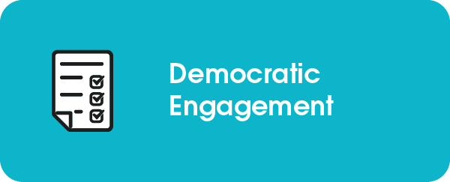

Brent Council

Digital Inclusion at Brent Council
Brent Council’s digital transformation programme is underpinned by an investment in the digital inclusion of residents to support them with digital skills, access to devices and connectivity and supporting each resident who wants to get online to do so. Brent is committed to helping every resident improve their digital skills, job opportunities and boost confidence, so that nobody gets left behind with rapid changes in technology. The investment in promoting digital inclusion plays a crucial part in getting better outcomes for all communities.

As part of Brent’s Digital strategy, we have been working to address digital exclusion by providing solutions for residents and businesses not only by supplying over 3,000 devices to digitally excluded individuals but assisting them with essential training to help them get connected. This included our Digital Support Fund for Businesses where 100 SMEs received devices, training, and connectivity to support their business get online and adapt to changing consumer habits. Alongside this, over 900 pupils received devices and connectivity in our first two rounds of support for young people, allowing them to participate in online homework sessions and develop their digital skills. As well as this, all eligible residents are able to apply for the Digital Resident Support Fund which provides digitally excluded residents with a device and 12 months free fibre connectivity in their home. To ensure the sustainability of residents remaining digitally included we have also worked closely with local fibre providers to develop a Brent resident social tariff for £5 per month.

The digital inclusion programme also recognises the importance of different resident needs and therefore have a variety of types of devices and connectivity that can be provided. One example of this is the initiative for homeless residents which provides residents with a mobile device and up to 12 months mobile data through the Good Things Foundation databank. By providing devices which have the flexibility to be used in multiple different locations it has enabled these residents to remain digitally included if they move to a different property. To ensure that these devices also deliver the expected benefits, each recipient is supported to develop their digital skills by a voluntary partner using the LearnMyWay platform.

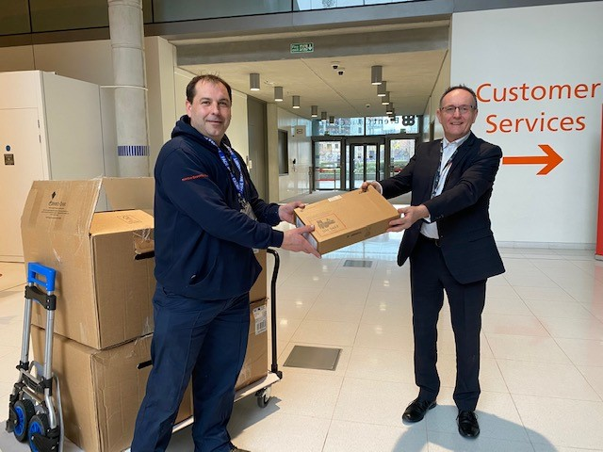
Brent has distributed over 3,000 digital devices to digitally excluded residents.

We have also introduced digital champions within our front-line and community and voluntary services to support residents with digital queries and assist them to develop their knowledge of different technologies. This approach supports a ‘Make every contact count’ model for promoting digital skills as part of every interaction with council services. We currently have over 200 digital champions across libraries, Brent Hubs, AgeUK and health partners.

The digital inclusion programme recognises the important role our community and voluntary partners play in assisting residents to get online. That’s why we have established a Digital inclusion network which has over 100 partners as members. The network meets on a regular basis to problem solve digital exclusion issues in the borough, promote different opportunities for providing support and as a means for collaboratively developing the council’s digital inclusion programme. Most recently the network and the residents which are supported through the work have been crucial in completing a detailed analysis of the current digital needs of the borough and current digital exclusion levels as part of our data analysis with Yonder.
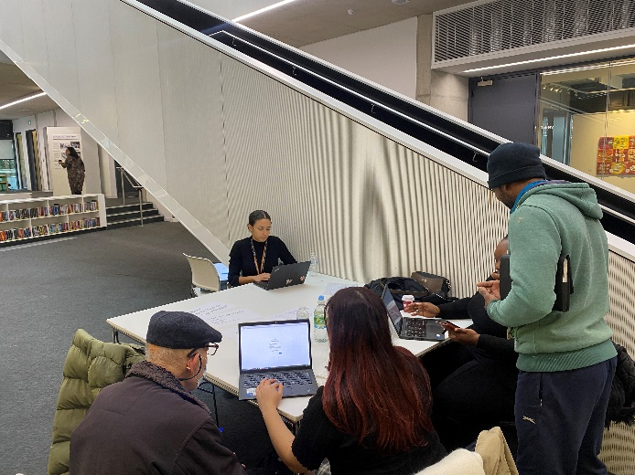
Digital drop-ins take place at Community Hubs to assist residents with accessing council and universal online services.

Alongside this, a digital platform called Springboard, provides residents access to over 2,000 technology-related courses. Over 50,000 residents have accessed this platform, and this is now being accessed by residents and businesses across London. Helping residents upskill means they can access council services more easily through online channels if they want to, improving accessibility and, potentially, the citizen experience. Having a digitally skilled resident base also improves employability, creating an economically stronger community and lowering dependence on the council. And it can help attract more businesses and investment into the borough who want to access a digitally enabled talent pool. It becomes a virtuous circle.

Altogether, Brent council recognises the importance of supporting residents to become digitally included, not only to improve their experience when interacting with the council but also supporting them to access universal services and opportunities that are available via the utilisation of technology.
___________________________________________________________________
For further information contact:

Madeleine Leathley
Head of Digital Transformation – Brent Council
Madeleine.Leathley@brent.gov.uk| 020 8937 2651 | www.brent.gov.uk

