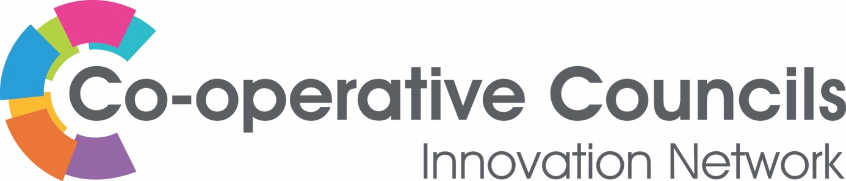

CO-OPERATIVE DEVELOPMENT
Plymouth City Council

Title: Officer and Member Roles in the development of Four Greens Community Trust, Plymouth
Plymouth City Council (PCC) set up a Community Economic Development Trust in the north of the city, centred around the regeneration of a disused care home and embedded in the community through a co-operative structure. The FGCT runs a wellbeing hub as well as associated assets that are used for community energy schemes and local employment. Further asset transfers are planned that will address housing, skills and employment needs.
The project stemmed from a commitment in the 2012 election campaign by Plymouth Labour Party ‘We will begin the process of creating a new Community Economic Development Trust for the north of the city, to replicate the success of Wolseley and Millfields Trusts in an area needing employment opportunities.’
After the election, a cross-departmental group of council officers was instructed to deliver on the commitment. The team was led by the Land and Property team and included officers from the Economic Development Service, Homes and Communities, Planning, Policy and the Neighbourhood Regeneration service.
James Watt, now Head of Land and Property; Patrick Bowes, Economic Development Manager; Debbie Burton, Community Connections Operational Manager; Darin Halifax, Policy Advisor; and Patrick Knight, Economy, Partnerships and Regeneration Manager are still with the council and still supporting the project delivery. Their initial task was to explore existing assets and to develop a ‘community capacity statement’ that explored community needs.
These studies were used to procure Locality as consultants “to determine how best to establish a new CEDT that will bring about improved community economic opportunities and community cohesion in the north of the city.”
Politically, the project was led by the Cabinet Member for Co-operatives and Community Development, Councillor Chris Penberthy. In January 2013, the council’s Cabinet approved recommendations to allocate £50,000 from cost savings, hold 11 sites for feasibility and business planning and involve the community in the project. Then, in October 2014, Cabinet approved in principle, the transfer of the derelict Whitleigh Care Home to become the Trust’s hub along with revenue funding and 2 Councillors as representatives on the Board. The project continued to be supported by all sides during its development.
The Voluntary and Community Service provider’s contract included a requirement to “Support the establishment of the proposed new Community Economic Development Trust for the north of the city, by engaging with residents, local groups, and other stakeholders to create and participate in new governance structures and CEDT activities.” This was delivered in 2013 by Plymouth based Zebra Collective which is a worker co-operative that delivers facilitation, consultancy and training for social justice.
By August 2013, the Council’s Homes and Communities service had conducted almost 100 detailed community surveys. Then, the following year, a summer programme of events was used to engage new members of the proposed co-operative, which involved taking a blow up sofa to the area to invite people to sit and chat. This also involved the regeneration team of the Economic Development Service and extra communications were undertaken as part of a wider Co-ops Fortnight communications campaign each year. The fire service’s community safety Blue Bus was used for some of the activities.
The framework for the first business plan was finalised by the regeneration team in December 2013, and provided a timeline for identification of the preferred community assets and production of a business case to support their transfer in the following year, then employment of a business development manager to implement the project. This was the report that first promoted the ideas of a solar array site and a community health care centre although these were just two of a long list of ideas to provide employment and services.
University of Plymouth’s Business School was engaged by the regeneration team to run the first Board Development Workshop in August 2014. A subsequent series of workshops helped the Board to plan the co-operative’s development. Co-operative Development Body The Fruit Tree for Business also worked with the shadow Board to investigate options for incorporation.
The Trust was incorporated as a co-operative Community Interest Company in October 2014 and held its first AGM to appoint the Steering Group members as the first Directors including local Labour and Conservative councillors.
In May 2015, the project received £90,000 from the council’s Social Enterprise Investment Fund (SEIF) to employ the project’s first Business Development Manager through the Economic Development service.
Late in 2015, just before solar subsidies were reduced, the Trust approached Plymouth Energy Community, another co-operative established by the council in 2013, to help turn derelict land into a community asset with a 4Mw solar array that was opened in March 2016.
The Whitleigh Hub opened in 2016 and in 2018, the council announced it as one of their new Wellbeing Hubs as part of the Strategic Commissioning Framework. Partners included NHS Northern and Eastern and Western Devon Clinical Commissioning Group.
In 2019, the Trust was contracted to act as Managing Agent for the sites which involved transferring financial responsibility. The Community Asset Transfer of the first 5 sites will be completed in April 2020 with an accompanying Service Level Agreement to ensure ongoing council engagement with operational activities of the Trust. This coincides with the launch of the Trust’s new 3 year strategy that was written following consultation with over 200 community members aged 6 to 91.

___________________________________________________________________

For further information contact:
Anna Peachey
Enterprise, Partnerships and Regeneration Manager – Plymouth City Council
anna.peachey@plymouth.gov.uk| 01752 307840 | www.plymouth.gov.uk

