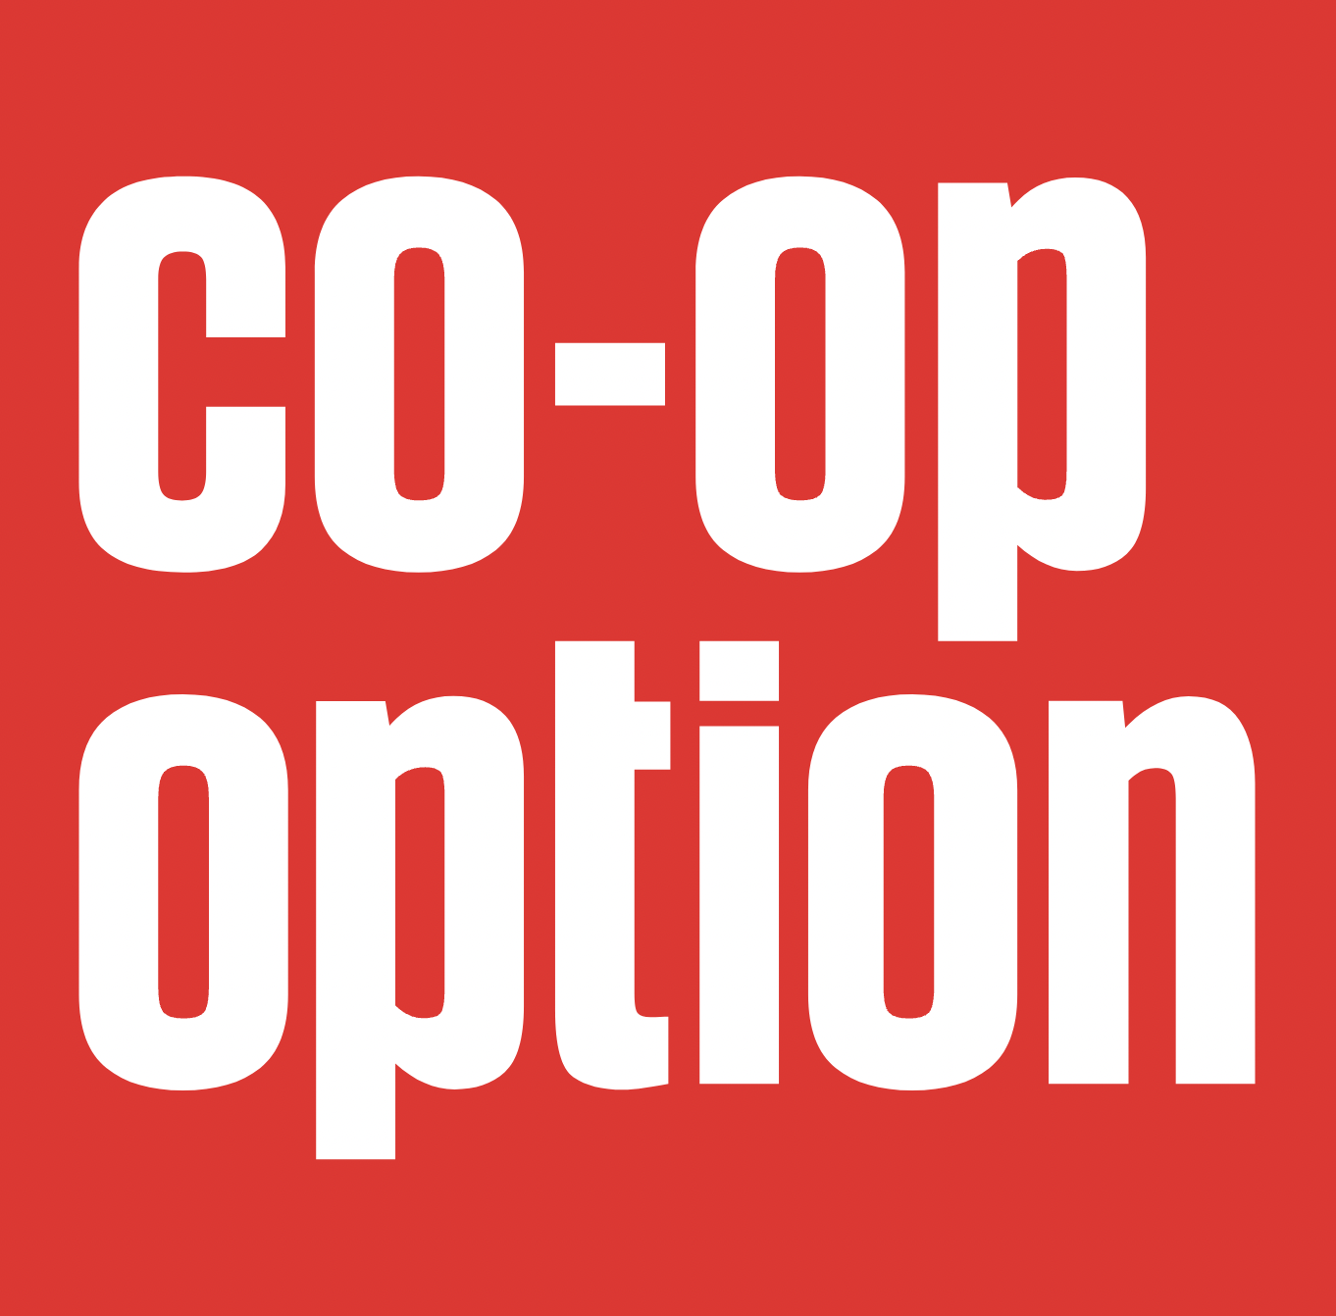

Follow-up resources
The Alternative Business movement is an extensive landscape of membership federations, financial institutions, development bodies, and informal networks. This simple guide is a starter pack to outline the active organisations and support offers available across the UK.

If you have any follow-up questions or requests for support, you can contact us on hello@stirtoaction.com.

Development Bodies
Co-op Culture
A co-operative consortium of co-operative and community advisors, entrepreneurs and enterprises. Members and associates have a vast and varied experience of supporting co-operative, community and social enterprise to start and grow.

Stir to Action
An economic development co-operative using the power of democratic ownership to transform economic inequality, the climate emergency, and wider society.

Co-operatives UK
The UK’s federation for co-operatives, and “the voice for the UK’s thousands of independent co‑ops” providing support to co‑ops to start up and thrive.

Plunkett Foundation
A national charity that supports rural communities across the UK to tackle the issues they face through community business.

Power to Change
The independent trust that strengthens communities through community business, and uses its experience to bring partners together to fund, grow and back community business to make places thrive.

Co-operative Development Scotland
The arm of Scotland’s enterprise agencies that supports company growth through employee ownership and cooperative business models. They provide support to companies and community groups who want to adopt employee ownership or co-operative business models such as consortium and community co-operatives.

Cwmpas
A development agency working for positive change, in Wales and across the UK. They are a co-operative focused on building a fairer, greener economy and a more equal society, where people and the planet come first.

Sharenergy
Sharenergy helps communities to set up and own renewable energy societies.

Membership Bodies

Co-operatives UK
The UK’s federation for co-operatives, and “the voice for the UK’s thousands of independent co‑ops” providing support to co‑ops to start up and thrive.

Workers.coop
The UK’s new federation for worker co-ops, working together to build a more equitable and sustainable world. They value collaboration, solidarity and care for each other, our communities, and our planet. Together we can make work decent, and empower people to shape their own destiny.

Locality
Locality is the national membership network supporting local community organisations to be strong and successful

DTAS
DTA Scotland is an independent, member-led organisation which aims to promote, support and represent development trusts in Scotland.

Support Programmes

Barefoot
A six-month programme that provides business practitioners with specialist training to gain skills, knowledge, and confidence to work as advisors in the co-operative and community business sectors.

Business Support for Co-ops
From up to six days of tailored support and mentoring, to digital tools and events, Co-ops UK’s programme can help businesses to start or grow a co-operative.

Make it Happen: Fundraising and Income generation
Up to 6 days of bespoke support, tailored to Big Local areas, covering fundraising and income generation, provided by Stir to Action.

UnFound
Is for founders looking for a different way to set-up and run a platform business. It brings together entrepreneurs that would like to develop their digital business in a more collaborative and equitable way. More information.

Finance & Funding

Reach
Supports charities and social enterprises to raise investment, the programme offers grants on average between £5,000 and £15,000.

Community Shares Booster Fund
Development grants and equity match investment (up to £100,000).

Community Ownership Fund
A £150 million fund over 4 years to support community groups across England, Wales, Scotland, and Northern Ireland to take ownership of assets which are at risk of being lost to the community.

Resonance
A social impact property fund manager, which launched in 2002 with the mission of connecting capital to social enterprise, offering Community Asset, Community Development, and Residential Property funds.

Ethex
Ethex is the positive savings and investment platform, enabling organisations to access new sources of investment from its 15,000+ strong investor base who are keen to generate social, environmental, and financial returns from the products they invest in.

Co-op & Community Finance
Co-operative & Community Finance is the trading name of the ICOF family of businesses.
Industrial Common Ownership Finance Ltd (ICOF) was set up in 1973 and has since created a number of related funds, all of which are democratically owned and controlled by the members. They provide sympathetic loan finance to help people take control of their economic lives and create social benefit, and exclusively serve the co-operative and social enterprise sector.

Loans for Enlightened Agriculture Programme
LEAP offers loans between £10,000 and £100,000 with some accompanying grant, plus business advice and support, to small agroecological businesses which are producing good food for their local communities.

Guides
What Is A Co-op?

Simply Legal

Simply Governance

Simply Start-up

Do-ocracy handbook

From Conflict to Co-operation

Co-operative development bodies (map)

Community Farmland Purchase Toolkit

Co-ops

Suma
Is the UK’s largest independent wholefood distributor. It specialises in vegetarian, fairly traded, organic, ethical and natural products. More information.

OrganicLea
A worker’s co-op and CIC growing food and community across Waltham Forest, offering a box scheme, plant sales, farm stall, volunteering, and training. More information.

Equal Care
A registered, multi-stakeholder co-operative, delivering a digital care and support platform that gives voice and power to the givers and receivers of care. More information.

Open Digital Co-op Ltd
The publishing platform created by councils, for councils. LocalGov Drupal, now Open Digital Co-op Ltd, is a publicly owned asset that delivers a better digital experience for citizens, improves service outcomes, and saves money. More information.

Community Business

Kitty’s Laundrette
We’re a community launderette and social space on Grasmere Street in the Everton area of Liverpool. We offer high-quality, affordable ecological laundry and dry cleaning services, as well as a space for people to gather, talk and learn. More information.

People Powered Retrofit
A not-for-profit service for householders in Greater Manchester and the North West, offering clear, independent advice and support to help you plan, procure and deliver your retrofit project to a high standard. More information.

Co-operative Care Colne Valley
Colne Valley Equitable Care Society Ltd (t/a Co-operative Care, Colne Valley – CCCV) is a multi-stakeholder co-operative established to provide both high-quality domiciliary care for older and disabled people in the Colne Valley, and fair and proper terms and conditions of employment for care staff. More information.

Keywords

Co-operative
A co-op is a business that’s owned and controlled by its stakeholder members to meet their shared needs. The members can be its customers, employees, residents or suppliers, who have a say in how the co-op is run.

Community business
Community businesses are locally rooted businesses that trade for the benefit of the community, are accountable to their community, and offer broad local impact.

Community Shares
Community shares are an effective and democratic way for communities to secure the assets they need. They are designed so that members of a community can put their money to work to purchase any income-generating asset that is needed by the community. This will keep the asset safe for future generations and in community ownership in perpetuity.

If you have any follow-up questions or requests for support, you can contact us on hello@stirtoaction.com.

