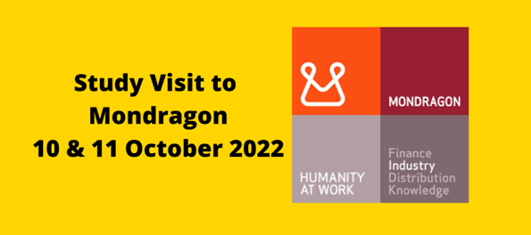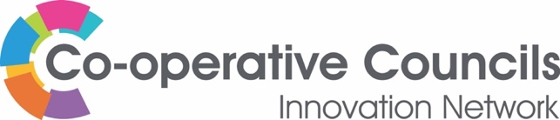

Mondragon Cooperative Experience:
9 -12 October 2022

Join us on our Study Tour and delve deeper into the phenomenon of 'Mondragon' to understand more about what a cooperative region looks like. The visit to Mondragon, in the Basque Country, Spain, is from Sunday 9th - Wednesday 12th October. Study days are the 10th and 11th. Travelling out on the 9th and returning on the 12th. On Tuesday evening, there are no direct flights to the UK from Bilbao (the closest airport).
The CCIN will fund:
- The lecture/tour costs (400 euros pp), including the lecture rooms, educational material, coffee/tea and lunch
- Bed and Breakfast at HOTEL MONDRAGON (Centro de Arrasate-Mondragon) www.hotelmondragon.com on Sunday, Monday and Tuesday
- Group Dinner on Monday evening
- A group booking will be made for dinner on Sunday and Tuesday for anyone wanting it. Those making alternative meal arrangements are responsible for meeting those costs.

Delegates will:
- Commit to attending the full two days of the visit (10 & 11 October), including dinner on Monday evening.
- Arrange and pay for their own travel arrangements from the UK to Bilbao. There are direct flights to Bilbao from Bristol, Gatwick and Manchester at around £150 return
- Fund their own meals if not joining the CCIN group booking
- Provide their flight details to Nicola Huckerby to coordinate arrival times

Places will be allocated 'first-come-first-served’ basis; priority will be given to Full Member Councils. Only those that have paid their membership fees for 2022/3, before the visit, will be eligible to attend.

The CCIN will set up a WhatsApp Group for everyone attending the visit and will use this medium to contact participants where possible.
Maximum of two funded places per organisation.

Next steps

Once a place is confirmed, participants can make their travel arrangements. The CCIN will not be responsible for the availability of flights once a place has been confirmed.
Unfunded places will be considered for anyone wishing to join us.

Booking form

Please complete for each participant.

I have read and agree to the terms of the CCIN-funded study visit to Mondragon taking place from 9 - 12 October 2022.

Full Name and title: .......................................................................

Job Title: .........................................................................................

Council / Organisation: ..................................................................

Contact email: ................................................................................

Mobile number (for WhatsApp Group) .........................................

Dietary requirements: ..................................................................

Accessibility requirements: ..........................................................

Dinner required:

Sunday 9th October
Monday 10th October
Tuesday 11th October

Hotel required:

Tuesday 11th October (You have the option to spend one night in Bilbao at your own expense)

If we can arrange group transport from the airport to the hotel on Sunday and from the hotel to the airport on Wednesday, would you be interested? This will depend on flight times.

Details of anyone else you would like to add to the contact list (PA, diary secretary etc):

.................................................................................................................................................................

SIGNED .........................................................................

Please sign and complete the booking form and return it to:

Nicola Huckerby
Operations & Communications Lead
Co-operative Councils’ Innovation Network

Email: comms@councils.coop | Mobile: 07813 687 292

