HEALTH & SOCIAL CARE

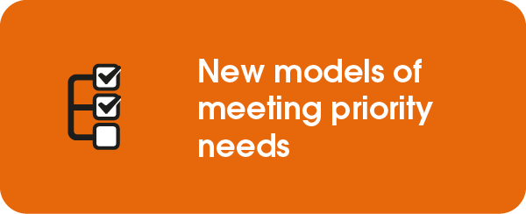

South Tyneside Council

Supporting People with Dementia to Live Better Lives
A partnership between South Tyneside Council and Age Concern Tyneside South has resulted in improved day opportunities for people with dementia. For the first time, both community and building-based support is on offer, depending on the nature and progression of the illness.

The new model for day opportunities sees staff from Age Concern talking to people to
identify their needs, interests and aspirations and help them access community support
to promote independence and wellbeing. This will enable people with dementia to remain
connected to their communities and reduce social isolation, whilst providing carers with a
much-needed break from their caring role.
By co-producing a solution with Age Concern and placing more of an emphasis on talking to people about their aspirations, more person-centred care can be delivered to help people to live better lives by achieving the things that really matter to them.
For those with more advanced dementia, day opportunities are provided at a purpose-built centre for residents, with sessions now running seven days a week – an increase on the five days previously offered. Those attending can take part in arts and crafts, watch a film, play music or games or just chat.

The new model is helping the Council deliver on its priority of supporting older or vulnerable communities.

Resident Alan Atkinson, 72, is one of those who accesses day opportunities.

His daughter, Corrina Roche, added: “I was a little apprehensive dropping my dad off at the centre as he has been stuck in the house for nearly two years, so it was a massive change for him. However, I need not have worried as he came out of the centre very happy, and he couldn't praise the staff enough.

“It's a great service that is much needed for the people of South Tyneside and it is allowing their families to have a break for a few hours, knowing their loved ones are safe and happy at the centre.”

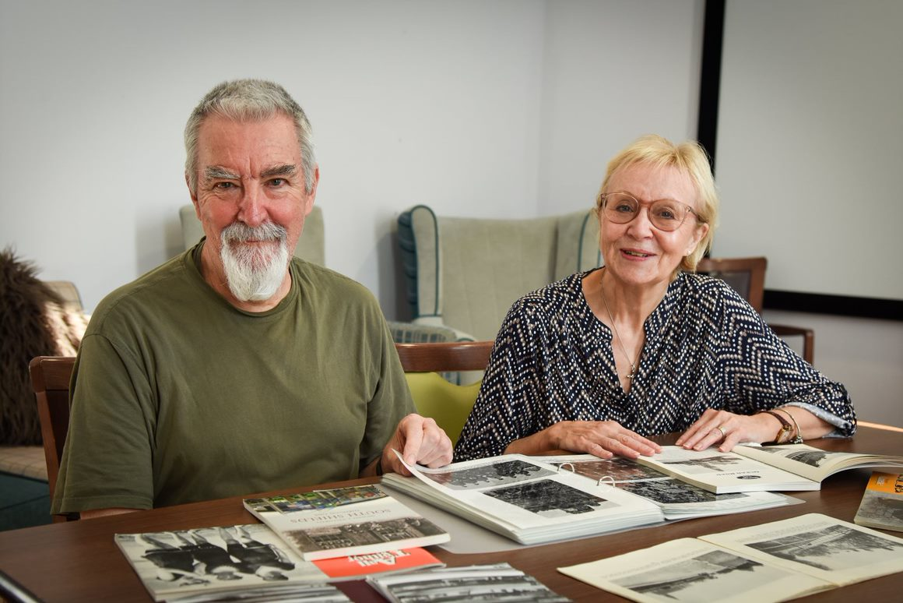

Caption: Dementia day care user, Alan Atkinson looking at old photographs of South Shields with Councillor Anne Hetherington, Lead Member for Independence and Wellbeing.

___________________________________________________________________

For further information contact:
Vicki Pattinson
Director of Adult Social Services and Commissioning, South Tyneside Council
vicki.pattinson@southtyneside.org.uk | 0191 424 4749 | www.southyneside.gov.uk

