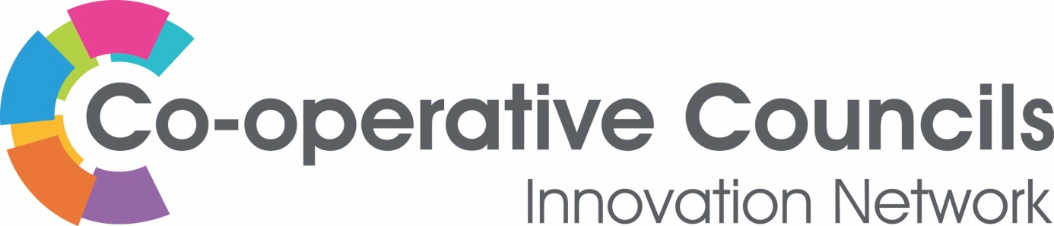

STRATEGY

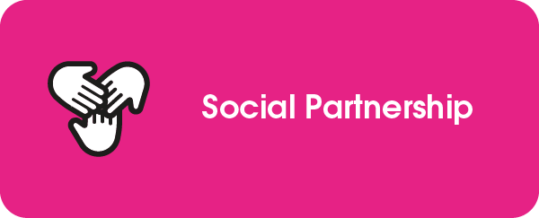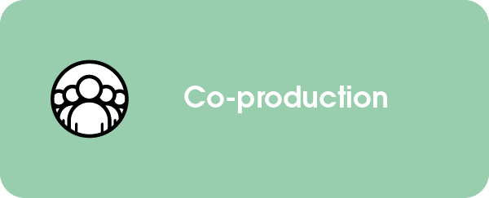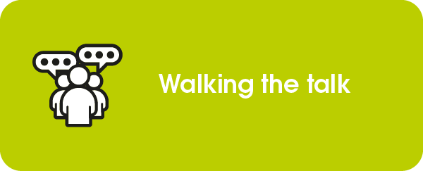

Greater Manchester Combined Authority

Shifting the Strategic Super-Tanker – putting wellbeing and equality at the heart of our strategies and actions
In October 2021, Greater Manchester Combined Authority provided a case study for the CCIN which highlighted the work of the Greater Manchester Independent Inequalities Commission and the Institute of Heath Equity Build Back Fairer in Greater Manchester. Since then the Combined Authority and its partners have been working to embed the recommendations from these reports at the heart of strategy and action, making tackling inequality ‘business as usual’.

Together, these reports provided 48 separate recommendations across a range of thematic and operational domains. Woven into the reports were further suggestions and encouragement to modify our focus in Greater Manchester – putting a greater emphasis on inequality and inequity. The Build Back Fairer work also gave us a framework for action and a set of Beacon Indicators which would show us whether we have been successful in driving down health inequality in the city region.

The challenge was clear – and our politicians confirmed their acceptance of that challenge.

The Essential Pivot
Both reports called for wellbeing and equality goals to be put at the heart of the Greater Manchester Strategy, with public budgets and projects all geared towards redressing imbalances by building a strong economy and working with residents to deliver the best possible services. The Greater Manchester Strategy is where the Combined Authority, together with its GM stakeholders set out our shared vision and ambition, and the alignment of messaging, direction and action around it will be key to creating this ‘essential pivot’. But to do this we would need to shift the strategic super-tanker and move away from the thematic silos around which our work was previously organised (and is still resourced).
Co-production
As the Independent Inequalities Commission pointed out ‘The challenge for Greater Manchester is to combine clear leadership from the top on prioritising Inequalities, with being brave enough to share power with those most affected by inequalities’. Co-production of the Greater Manchester Strategy would be the key to its success.

Starting with a complex exercise of mapping stakeholders, GMCA reached out to partner organisations and structures, to its 10 constituent local authorities and their partners, to the business community, and to voluntary, community and social enterprise organisations. We also engaged communities of identity via our GM Equalities Panels and to those affected by poverty and socio-economic inequality. The conversations started with reflection on what had gone before, moving to shared opportunities and aspirations, before identifying the ’cross-cutting’ issues and enablers of success.

To inform the work of the Independent Inequalities Commission, GMCA used its online engagement platform to capture resident views. The Combined Authority also has a bi-monthly insight survey, established at the beginning of the Covid pandemic, but maintained to build understanding of how our residents feel, how their lives are being impacted by the pandemic or the cost-of-living crisis, and to inform our policy development.

Stakeholder engagement during the development of the Strategy gave us several ‘lightbulb’ moments, including:
- The Greater Manchester Strategy should provide a central core around which our many thematic strategies and plans should pivot
- It should enable distributed leadership. ‘Levelling up’ within Greater Manchester should happen from the bottom up - not seek to control activities from a GM level.
- The Strategy should be supported by detailed knowledge of inequality across places and communities. Headline progress measures, targeted indicators and qualitative assessments should form the basis of a comprehensive performance framework and progress monitoring.
- Delivering our shared Outcomes and Commitments will depend on how we work, as much as what we work on.

The Greater Manchester Strategy
Launched in March 2022, the result is not just a glossy document that resides on shelves and in digital archives. About Greater Manchester contains a vision / central pivot of ‘good lives for all’, supported by the three pillars of a greener, fairer and more prosperous city region. It has a suite of outcomes – and a measurement framework to monitor progress made which embraces the Build Back Fairer Beacon Indicators. There are 15 commitments against which action will be taken (and evaluated). All this is underpinned by a strong foundation formed from agreed ways of working. We are adopting practices which will enable a consistent approach across systems, institutions and communities to come together. Finally, case studies are provided to illustrate the types of activities and ways of working that we would like to replicate and spread.
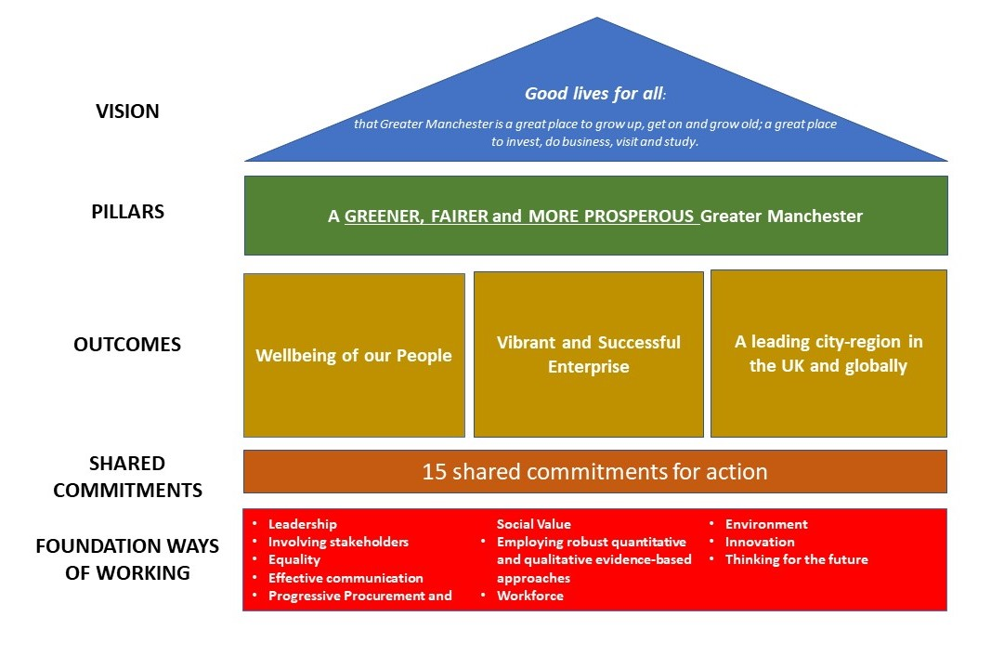

The Independent Inequalities Commission – One Year On…
In March 2022. GMCA invited the Inequalities Commissioners back to review our work. The Commission noted progress on ‘process’ being made, but they highlighted that, one year on, the world is different: inequalities, poverty, and deprivation are set to increase at a time when we had all hoped to be focused on building back better. Under this new reality the Commissioners called for more courage, creativity, innovation and action. Our next steps therefore are to accelerate the work that we have put in train.

___________________________________________________________________

For further information contact:
Anne Lythgoe
Principal, VCSE Accord Implementation - GMCA
Anne.Lythgoe@greatermanchester-ca.gov.uk | www.greatermanchester-ca.gov.uk

