STRATEGY
Branding.coop working with the CCIN

Building the Co-operative Council Network
Established in 2016, branding.coop provides hands-on support and guidance to organisations wishing to promote their cooperative identity.

Since June 2016 Nicola has managed the operations and communications for the Co-operative Councils’ Innovation Network, providing a central point for CCIN Members, prospective members and other organisations wishing to find out more about the Network.

Committed to exceeding expectations, services comprise:

- Communications & Marketing – production and dissemination of member communication via publications newsletters, member promotions, member specific news, WhatsApp Groups etc. Brand guardian for the CCIN’s visual identity
- Event Strategy – planning, organising, and attending events, conferences, exhibitions (in person and online) on behalf of the Network acting as an Ambassador and Spokesperson.
- Website strategy – managing and updating content on the Councils.coop website including, the collation of case studies, blogs, member news and publications. Case Studies have grown from 70 to 330 over the last five years. Curating the scope and content of a new website, to be launched in Autumn 2021.
- Social Media management, engagement, and content – managing the reputation and profile of the Network on Twitter, Facebook, and LinkedIn
- Membership recruitment, servicing, and retention – Since 2016 the number of members has grown from 20 councils to over 100 members and supporter. Overseen the creation of four categories of membership: Full, Associate, Affiliate, Supporter.
- Provision of CCIN Secretariat and Governance Support – organising Governance meetings, managing agendas, taking minutes, recording, and tracking decisions and actions.
- Officer Network Support – engaging officers in Network activity, organising monthly calls, managing agendas / inviting speakers
- Project management, monitoring and tracking – the number of funded projects delivered by Network Members has grown from six in 2016 to 40 projects in 2021.
- CRM & GDPR – as the Network has grown, so has the volume of member data. Contacts have grown from c100 email addresses to >1000 contacts across seven audiences.
- Strategy and Action Plan – managing monitoring and tracking delivery, and in most cases delivering the actions.
- Dynamic Purchasing System – promoting the DPS and managing relationships with Suppliers.

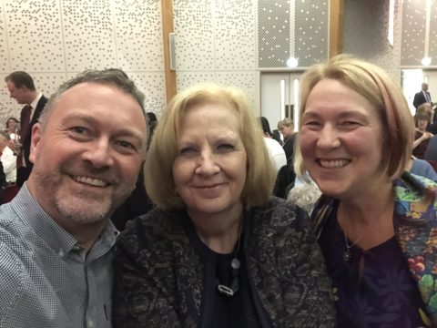

L:R Steve Reed MP, OBE - CCIN Honorary President, Cllr Sharon Taylor OBE - Chair of the CCIN and Leader of Stevenage Borough Council, Nicola Huckerby - Branding.coop
___________________________________________________________________

For further information contact:

Nicola Huckerby
Director – Branding.coop
hello@branding.coop | 07813 687 292 | www.branding.coop

