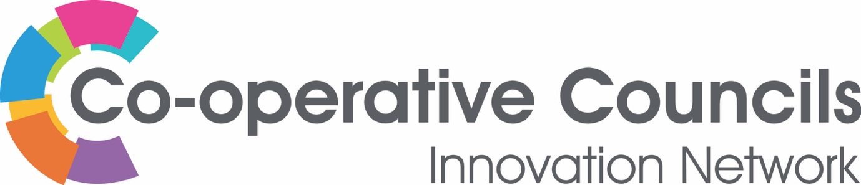

CCIN innovation funding – 2022 Policy Prototypes

Our Policy Prototype Funding this year asks that Members think creatively about co-operative solutions to the current health and social care crisis in relation to Children and Young People’s Services – for services in-house or commissioned.
All applications will be considered for funding of £1500.
We’d expect that the majority of Policy Prototypes to have completed their work within 9 months. We are particularly interested in workforce and union engagement and involvement in developing new ways of working.
We’d like projects to be written up, and other resource materials made available to us – but we are not expecting these to publication level as we will be pulling all of the learning together into a one major policy and resource publication.
We welcome applications from all Members, but the application must be submitted, and delivery overseen by a Full Member Council, Town, Parish or Community Council, Political Group or other elected body.

Please return your completed EOI to comms@councils.coop
Applications will re-open in October 2021

Expression of Interest – Policy Prototype CCIN Funding 2022

CCIN Member Organisation submitting application: Click here to enter text.
Name of CCIN Lead Councillor/Officer: Click here to enter text.
Partner organisations: Click here to enter text.
Contact details (Email and phone): Click here to enter text.
1. What is your idea?
Provide details of what your proposed project is, the story of how you identified the need or opportunity for the proposal and how the money will be spent.
2. Who will you work with?
You are not required to work with other CCIN members when applying to deliver a Policy Prototype, though you are more than welcome to!
3. What are the outcomes you hope to achieve?
What are the outcomes you hope to achieve through this project and how will you know if your outcomes are achieved? What is your measure of success?
4. How does your project support the aims and objectives of the Co-operative Councils Innovation Network?
The Co-operative Councils Innovation Network aims to frame the debate on the future of sustainable solutions to public sector challenges. Our work will ultimately improve outcomes for communities by enabling members to develop radical innovation in policy and practice, sharing best practice and learning, and enabling innovators to chart new territory together. Please provide details of how your project will support this aim.

5. How does your project demonstrate the Values and Principles of the Co-operative Councils Innovation Network?
Our Network is based on the Co-operative values developed by the International Co-operative Alliance: “self-help, self-responsibility, democracy, equality, equity and solidarity… honesty, openness, social responsibility and caring for others”. Further details about the CCIN’s Values and Principles Statement here. Please provide details of how your project will demonstrate the CCIN’s Values and Principles.
6. How will you share your learning with the Co-operative Councils Innovation Network?
How will you share your learning with other CCIN members? How will you share your learning beyond the project? This could be through producing a report, holding a workshop or presenting at the CCIN’s annual conference.

