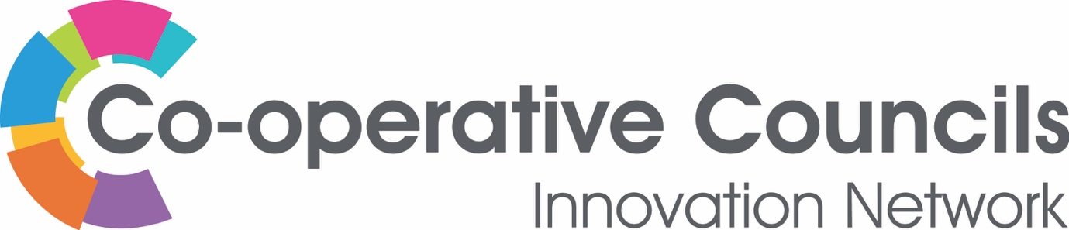

CCIN innovation funding – 2021/2 Policy Labs

Would you like to collaborate with other CCIN Members (Councils, Associates and Affiliates) to find co-operative solutions to the challenges facing local government? Is there a co-operative idea that you would like to run in your local area? If yes, we want to hear from you!
As a CCIN member you can apply for up to £10,000 to deliver a Policy Lab. This year we are making an Open Call for ‘Building Back Greener for economic and societal Recovery along with the future of work’. These are the suggestions we’ve had this year:
1. Identifying the key barriers to developing the co-operative economy
2. Connecting Co-operative Development and enterprise agencies to councils
3. Supporting the work of Mutual Aid Groups post Covid-19
4. Tackling Digital Poverty and the Digital Divide to help job search
5. Green Recovery, Carbon Reduction and Climate Change
6. Phase 2 Action Learning project: Capturing the Co-operative Council ‘crisis response’
7. Opportunities linked to Students / Universities / Co-op Start Up (and role/impact in Cities) on an inclusive economy agenda
8. Training in the Co-operative Values & Principles for Opposition Councillors
If you have an idea, please complete the expression of interest form below. We want to hear ideas from ALL our members. Policy Labs are designed for cross Member participation and we recommend engaging a minimum of three other CCIN members to create a working group to support the development of your project.
We welcome applications from all Members, but the application must be submitted, and delivery overseen by a Full Member Council, Town, Parish or Community Council, Political Group or other elected body.
Please return your completed EOI to comms@councils.coop, by 5pm Friday 27th November 2020.
We will be holding a joint meeting of our Executive Oversight Committee and Values & Principles Board on 25 January 2021 to assess applications, with a view to successful Bids commencing in February 2021.

Expression of Interest – Policy Lab CCIN Funding 2021

CCIN Member Organisation submitting application: Click here to enter text.
Name of CCIN Lead Councillor/Officer: Click here to enter text.
Partner organisations: Click here to enter text.
Contact details (Email and phone): Click here to enter text.

1. What is your idea?
Provide details of what your proposed project is, the story of how you identified the need or opportunity for the proposal and how the money will be spent.

2. Who will you work with?
A key requirement of Policy Lab Funding is that you work in partnership with other CCIN members. We recommend engaging a minimum of three other CCIN members (Affiliates and Associates should bid alongside Full Council members) to create a working group to support the development of your project.

3. What are the outcomes you hope to achieve?
What are the outcomes you hope to achieve through this project and how will you know if your outcomes are achieved? What is your measure of success?

4. How does your project support the aims and objectives of the Co-operative Councils’ Innovation Network?
The Co-operative Councils Innovation Network aims to frame the debate on the future of sustainable solutions to public sector challenges. Our work will ultimately improve outcomes for communities by enabling members to develop radical innovation in policy and practice, sharing best practice and learning, and enabling innovators to chart new territory together. Please provide details of how your project will support this aim.

5. How does your project demonstrate the Values and Principles of the Co-operative Councils’ Innovation Network?
Our Network is based on the Co-operative values developed by the International Co-operative Alliance: “self-help, self-responsibility, democracy, equality, equity and solidarity… honesty, openness, social responsibility and caring for others”. Further details about the CCIN’s Values and Principles is available here. Please provide details of how your project will demonstrate the CCIN’s Values and Principles.

6. How will you share your learning with the Co-operative Councils’ Innovation Network?
How will you share your learning with other CCIN members? How will you share your learning beyond the project? This could be through producing a report, holding a workshop or presenting at the CCIN’s annual showcase event.

