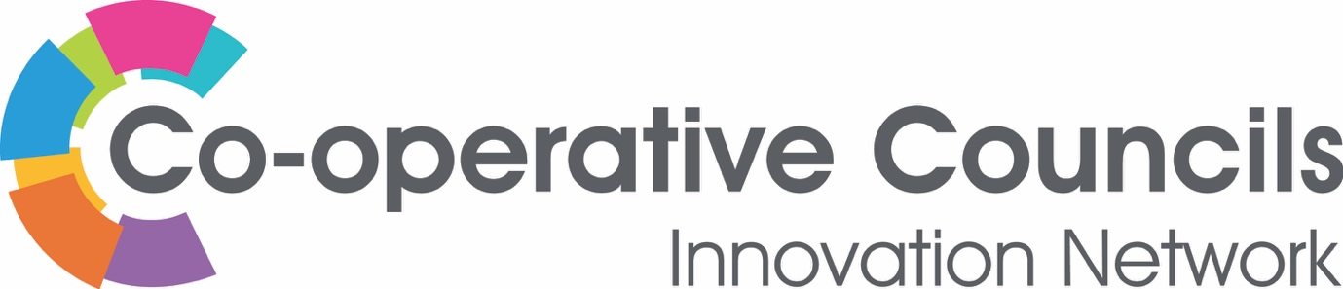

CCIN innovation funding – 2020 Policy Prototypes

Health & Social Care

We’re taking a slightly different approach to our innovation funding in 2020, because we want to ensure that as a Network we begin to think creatively about co-operative solutions to the current health and social care crisis. This year we:
- Will only be accepting proposals for Policy Prototypes about health and social care with funding of £1500 (for adults, for children or for both – for services delivered in-house or commissioned – Public Health, early intervention, prevention or delivery).
- Expect the majority of the Policy Prototypes to have completed their work within 6 months (and all within 9); similarly, we will be looking for any Policy Labs to submit interim findings within 6 months (and to have finalised their work within 12 months) of the work being awarded.
- Are particularly interested in workforce and union engagement and involvement in developing new ways of working.
- Need projects to be written up, and other resource materials made available to us – but we are not expecting these to publication level as we will be pulling all of the learning together into a one major policy and resource publication.
We welcome applications from all Members, but the application must be submitted, and delivery overseen by a Full Member Council, Town, Parish or Community Council, Political Group or other elected body.

Though we don’t intend to fund Policy Labs this year, we are always open to hearing from our members who have interesting, co-operative proposals. If you do have an idea for a bigger, Health and Social Care Policy Lab please let us know. Policy Labs can fund up to £10k of project development work but require significantly more effort than smaller Policy Prototypes.

We will be holding a joint meeting of our Executive Oversight Committee and Values & Principles Board early in the New Year to assess applications, with a view to successful Bids commencing in February 2020.
Deadline for applications is Friday, 20th December 2019 and will be processed as they are submitted. Please send completed application forms to comms@councils.coop.
Expression of Interest – Policy Prototype CCIN Funding

CCIN Member Authority: Click here to enter text.
Name of CCIN Lead Member: Click here to enter text.
Name and Job Title: Click here to enter text.
1. What is your idea?
Provide details of what your proposed project is, the story of how you identified the need or opportunity for the proposal and how the money will be spent.

2. Who will you work with?
You are not required to work with other CCIN members when applying to deliver a Policy Prototype, though you are more than welcome to!

3. What are the outcomes you hope to achieve?
What are the outcomes you hope to achieve through this project and how will you know if your outcomes are achieved? What is your measure of success?

4. How does your project support the aims and objectives of the Co-operative Councils Innovation Network?
The Co-operative Councils Innovation Network aims to frame the debate on the future of sustainable solutions to public sector challenges. Our work will ultimately improve outcomes for communities by enabling members to develop radical innovation in policy and practice, sharing best practice and learning, and enabling innovators to chart new territory together. Please provide details of how your project will support this aim.

5. How does your project demonstrate the Values and Principles of the Co-operative Councils Innovation Network?
Our Network is based on the Co-operative values developed by the International Co-operative Alliance: “self-help, self-responsibility, democracy, equality, equity and solidarity, honesty, openness, social responsibility and caring for others”. Further details about the CCIN’s Values and Principles are available here. Please provide details of how your project will demonstrate the CCIN’s Values and Principles.

6. How will you share your learning with the Co-operative Councils Innovation Network?

Deadline for applications is Friday, 20th December 2019. Please send completed applications to comms@councils.coop.

