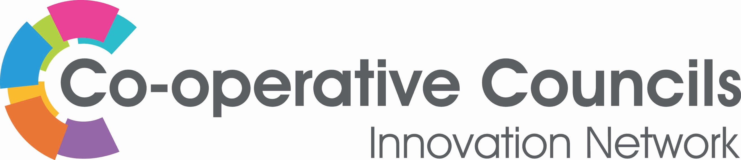

DIGITAL
Salford City Council

Digital You – Salford: a city-wide approach towards digital inclusion
Salford is a thriving cultural, economic and residential destination, home to 251,000 people and 10,500 businesses. Unprecedented levels of economic growth over the last decade, including renowned schemes, such as MediaCityUK, has transformed the city, creating one of the most highly skilled digital and technical workforces in the Greater Manchester city region.

Salford is aiming to become a Digital City, an ambition which forms part of our wider vision for a better, fairer Salford to improve resident’s lives. We are strongly committed to digital inclusion – making sure that residents have the capability to use the internet to do things that benefit them day to day.

To achieve this, Salford is working with Good Things Foundation (GTF), the UK’s leading digital and social inclusion charity which helps people to use and engage with digital to improve their lives. Digital You, which is part of Salford’s Digital Everyone plan, that aims to bring all the benefits of the digital world to almost 8,000 digitally excluded Salford residents by 2020. The programme is designed to support people to gain basic digital skills and build their confidence and capability to become independent users of computers and the internet. Courses cover: searching the internet, banking online, using public services online, staying healthy online, searching for a job online and more.

Residents are being engaged in digital through local community settings and helped to develop basic digital skills and confidence. The council has also been creating a social movement for change by involving stakeholders from public, voluntary and private sector, to pledge their support.

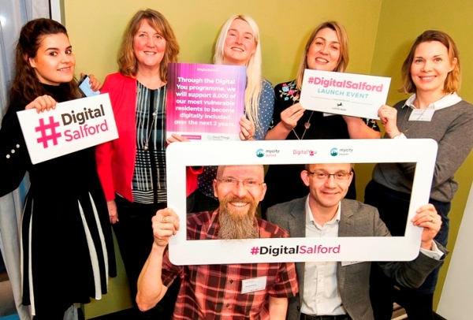

The project has brought community organisations across the city together joining the Online Centres Network, which offers a wide range of free benefits, including: access to a variety of training, online learning platform Learn My Way, and opportunities to link in with other organisations and schemes, including access to funding.

Since its launch in September 2017, Digital You has:

- recruited over 33 centres, such as community organisations or libraries, across the city, with more signing up every week,

- directly reached almost 1,000 residents and recruited over 80 volunteer digital champions, residents who don’t need to be an online expert but with enthusiasm for the internet and technology, and

- formed a partnership with Forest Bank Prison – the first such partnership in the UK – to create a positive impact on re-offending rates through providing support ranging from practical basic skills to more advanced skills, such as coding and web content design.

- View the pledges on the Digital Salford Launch event page

___________________________________________________________________

For further information contact:
Chris Howl
Policy and Equality Officer - Salford City Council
chris.howl@salford.gov.uk | Tel: 0161 793 3068

