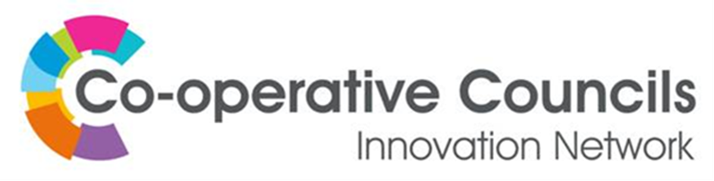
Do you require funding to deliver your project?
The CCIN has made funding available to help support the delivery of your Policy Prototype. You can apply for anything up to £1,500 for a Policy Prototype.
Applicants will be required to provide the CCIN Executive Oversight Committee with regular updates on project spend, as well as maintaining clear financial records in line with public spending requirements.
Please complete the expression of interest form below if you would like to apply for funding from the CCIN to support the delivery of your project.

Expression of Interest – CCIN Funding

CCIN Member Authority: Click here to enter text.
Name of CCIN Lead Member: Click here to enter text.
Applicant Name and Job Title: Click here to enter text.
Telephone Number: Click here to enter text.
Email Address: Click here to enter text.

How much are you applying for: Click here to enter text.

Lead Member’s Signature: Chief Executive’s Signature:

